A000-Maya-Tikal-Shaman seated transforming into Jaguar-Jade-500 CE

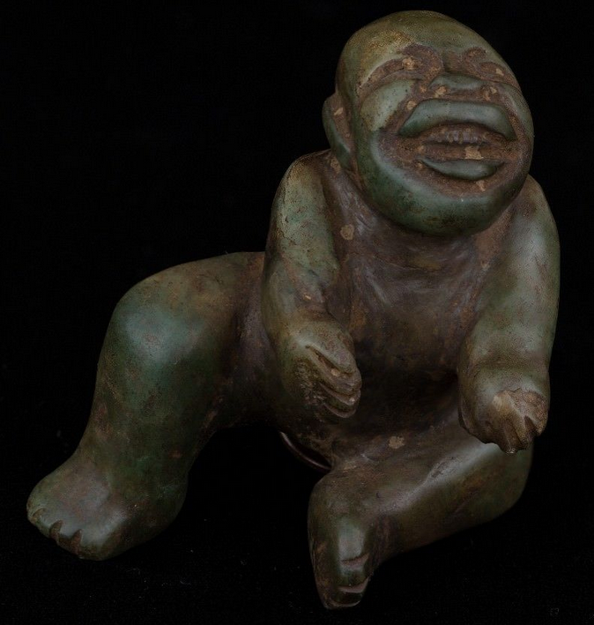 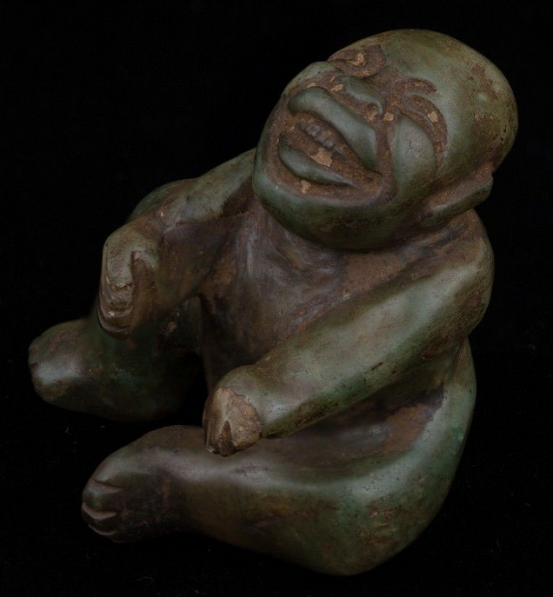

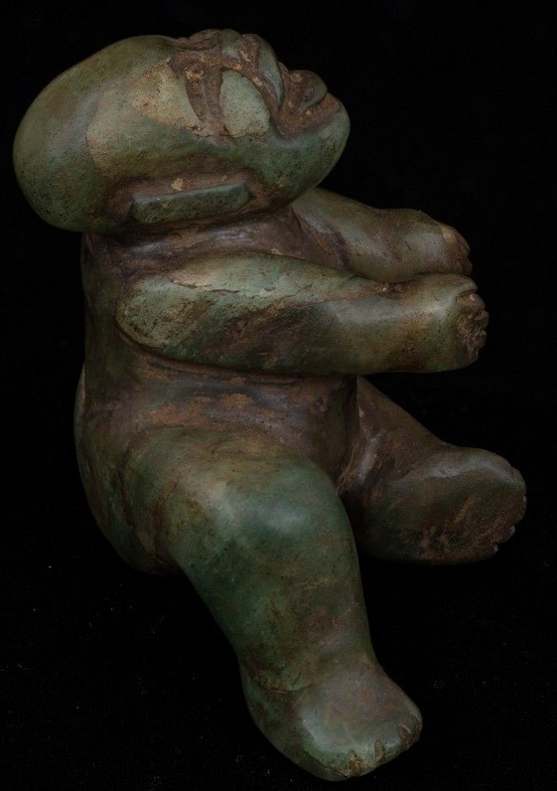 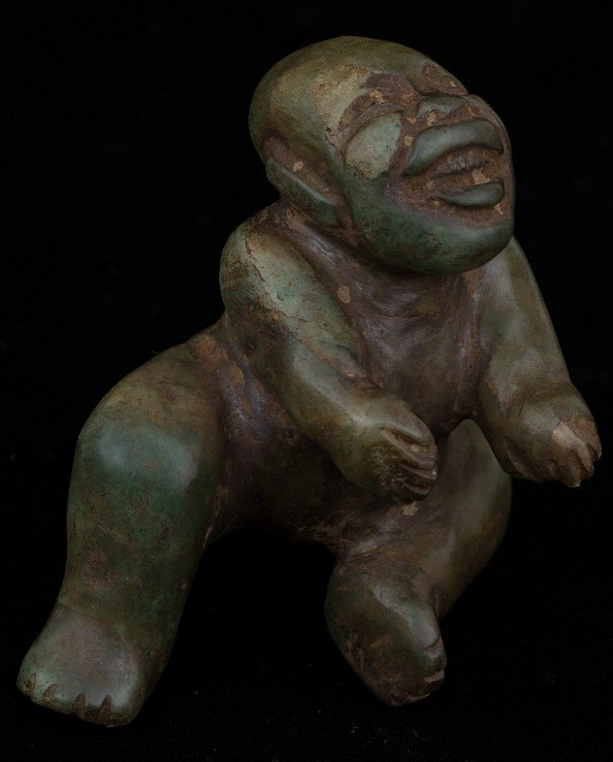

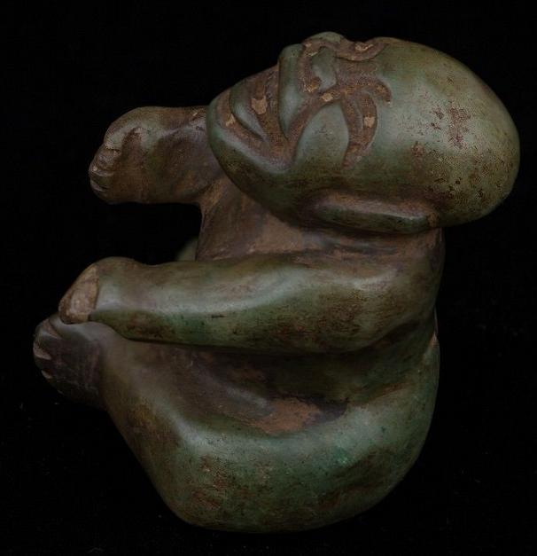 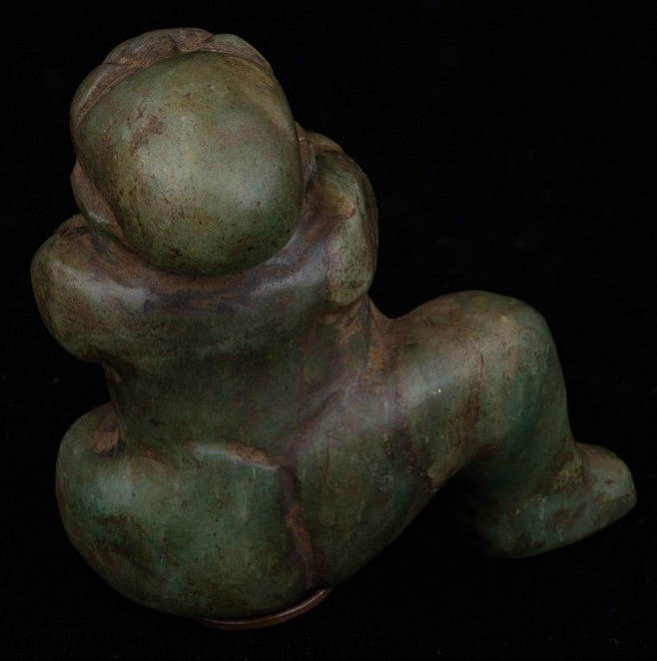

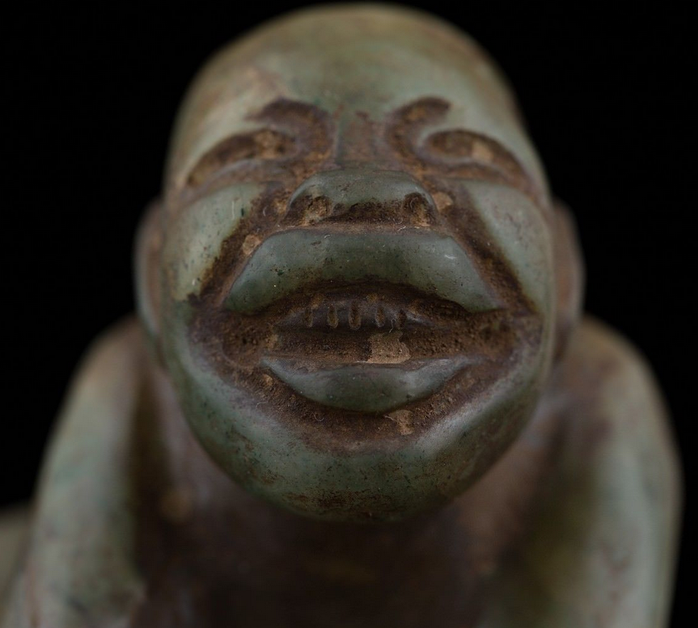 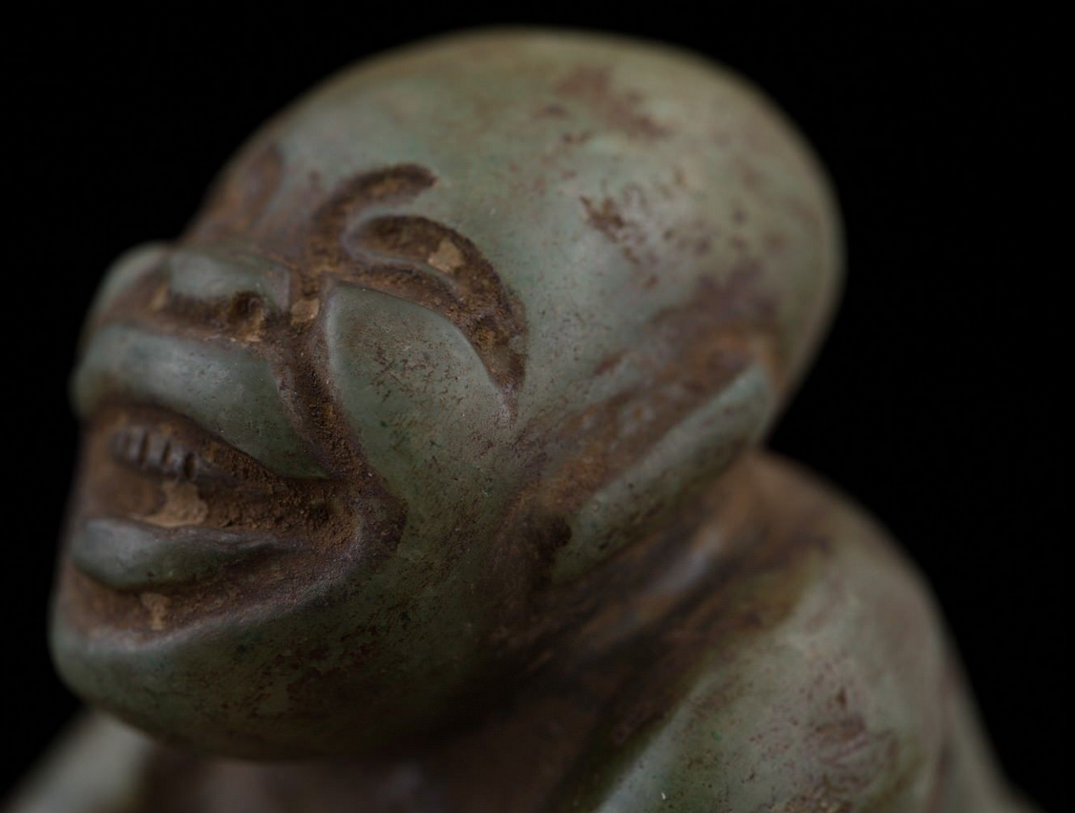

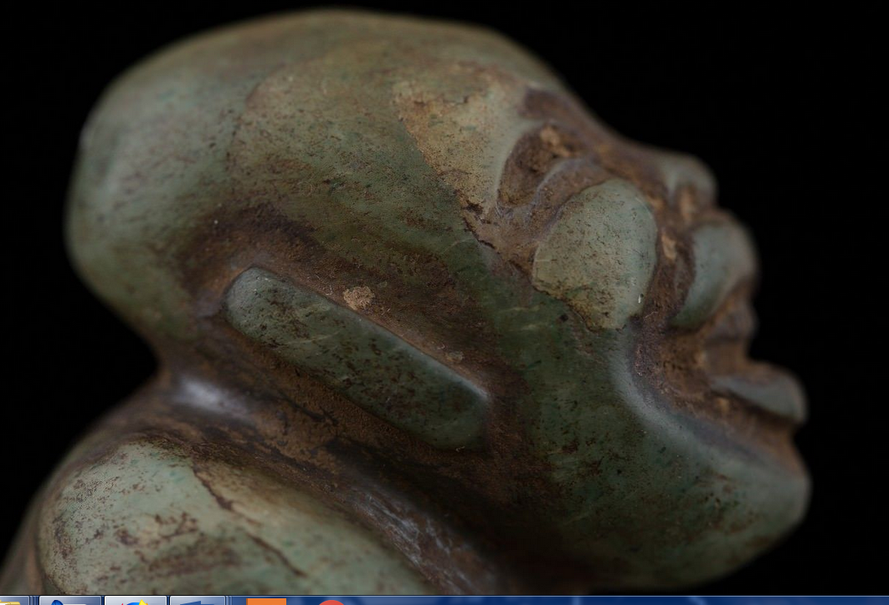 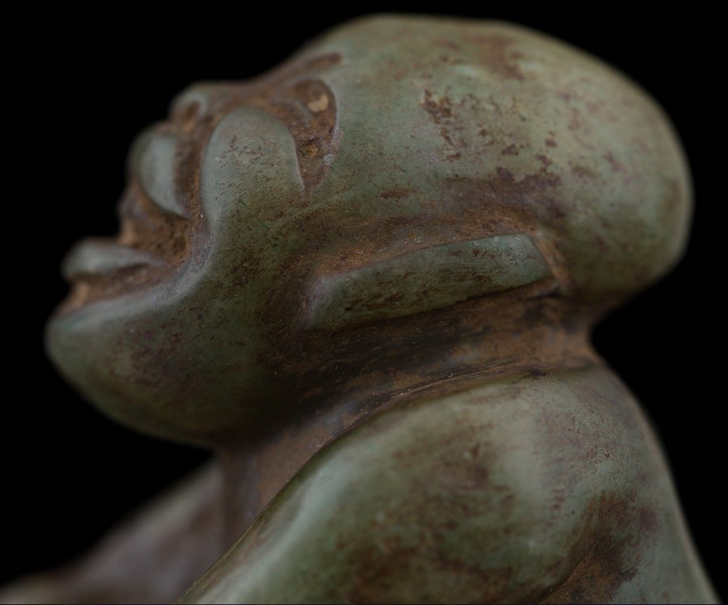

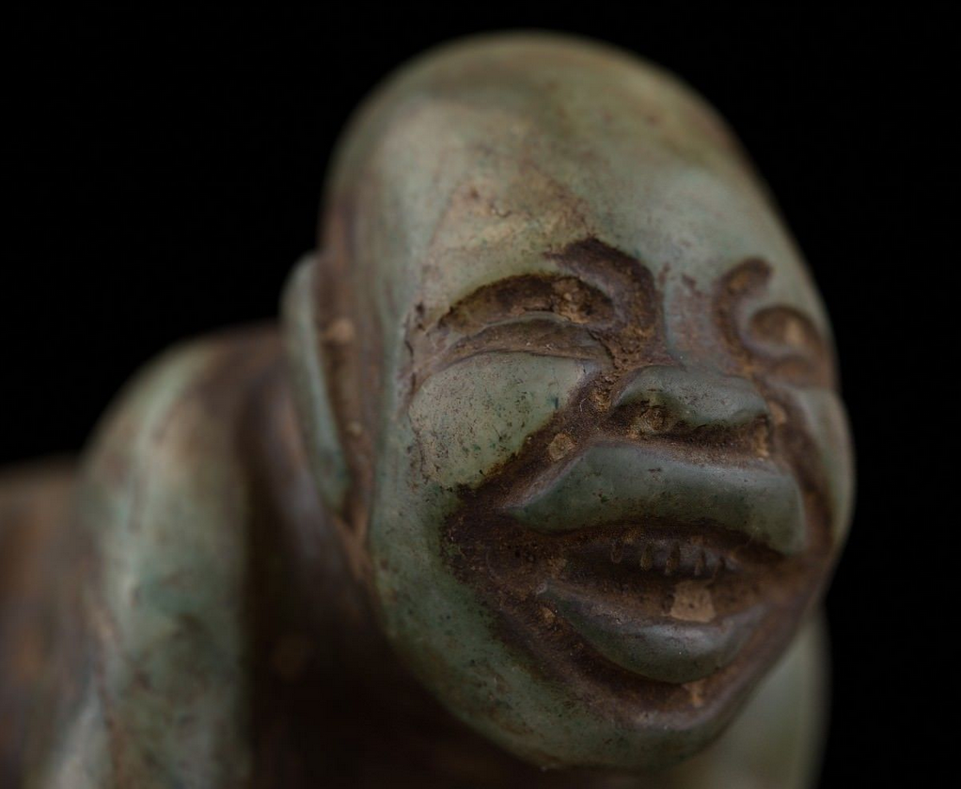

Figs. 1-11. Maya-Tikal-Shaman seated transforming into Jaguar-Jade-500 CE

**Case no.: 14**

**Accession Number:**

**Formal Label:** Maya-Tikal-Shaman seated transforming into Jaguar-Jade-500 CE

**Display Description: (Mostly after Wiki)**

**This superbly sculpted jade of a shaman transforming into a jaguar spirit was probably crafted in the Classic Period at Tikal when it was at the height of its artistic period.**

**Tikal** ([/tiˈkɑːl/](https://en.wikipedia.org/wiki/Help:IPA/English)) (*Tik’al* in modern Mayan orthography) is the ruin of an ancient city, which was likely to have been called **Yax Mutal**, found in a rainforest in Guatemala.[[2]](https://en.wikipedia.org/wiki/Tikal#cite_note-2) Ambrosio Tut, a gum-sapper, reported the ruins to *La Gaceta*, a Guatemalan newspaper, which named the site Tikal. After the Berlin Academy of Sciences' magazine republished the report in 1853, archeologists and treasure hunters began visiting the forest. Today, tourism to the site may help protect the rainforest.[[3]](https://en.wikipedia.org/wiki/Tikal#cite_note-3) It is one of the largest archaeological sites and urban centers of the [pre-Columbian](https://en.wikipedia.org/wiki/Pre-Columbian) [Maya civilization](https://en.wikipedia.org/wiki/Maya_civilization). It is located in the archaeological region of the [Petén Basin](https://en.wikipedia.org/wiki/Pet%C3%A9n_Basin) in what is now northern [Guatemala](https://en.wikipedia.org/wiki/Guatemala). Situated in the [department](https://en.wikipedia.org/wiki/Departments_of_Guatemala) of [El Petén](https://en.wikipedia.org/wiki/El_Pet%C3%A9n), the site is part of Guatemala's Tikal National Park and in 1979 it was declared a [UNESCO](https://en.wikipedia.org/wiki/UNESCO) [World Heritage Site](https://en.wikipedia.org/wiki/World_Heritage_Site).[[4]](https://en.wikipedia.org/wiki/Tikal#cite_note-4)

Tikal was the capital of a conquest state that became one of the most powerful kingdoms of the ancient Maya.[[5]](https://en.wikipedia.org/wiki/Tikal#cite_note-5) Though monumental architecture at the site dates back as far as the 4th century BC, Tikal reached its apogee during the [Classic Period](https://en.wikipedia.org/wiki/Mesoamerican_chronology), c. 200 to 900 AD. During this time, the [city](https://en.wikipedia.org/wiki/Maya_city) dominated much of the Maya region politically, economically, and militarily, while interacting with areas throughout [Mesoamerica](https://en.wikipedia.org/wiki/Mesoamerica) such as the great metropolis of [Teotihuacan](https://en.wikipedia.org/wiki/Teotihuacan) in the distant [Valley of Mexico](https://en.wikipedia.org/wiki/Valley_of_Mexico). There is evidence that Tikal was conquered by Teotihuacan in the 4th century CE.[[6]](https://en.wikipedia.org/wiki/Tikal#cite_note-6) Following the end of the Late Classic Period, no new major monuments were built at Tikal and there is evidence that elite palaces were burned. These events were coupled with a gradual population decline, culminating with the site’s abandonment by the end of the 10th century.

Tikal is the best understood of any of the large lowland Maya cities, with a long [dynastic ruler](https://en.wikipedia.org/wiki/Maya_rulers) list, the discovery of the tombs of many of the rulers on this list and the investigation of their [monuments](https://en.wikipedia.org/wiki/Monumental_sculpture), temples and palaces.[[7](https://en.wikipedia.org/wiki/Tikal#cite_note-7)

**LC Classification:**

**Date or Time Horizon:** 500 CE

**Geographical Area:** Tikal

**Map:**

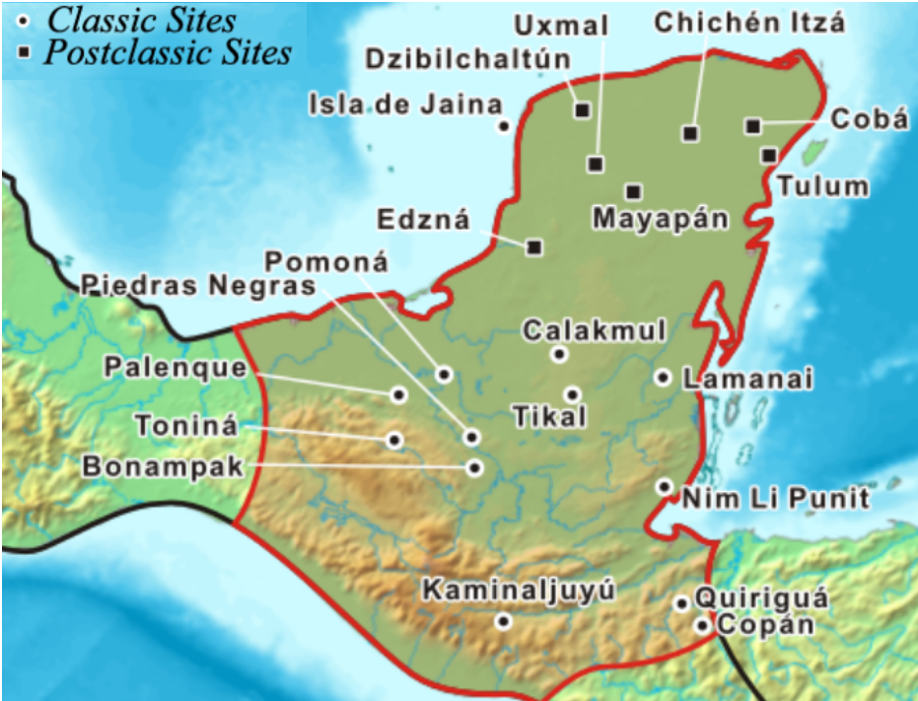

Mayan area after https://upload.wikimedia.org/wikipedia/commons/c/c5/Mayamap.png

**GPS coordinates:** [17°13′19.54″N 89°37′25.01″W](https://tools.wmflabs.org/geohack/geohack.php?pagename=Tikal&params=17_13_19.54_N_89_37_25.01_W_type:landmark)

**Cultural Affiliation:** Classic Mayan

**Medium:** Green Jade

**Dimensions:**

H 2 3/4 inches, W 2 1/2 inches

**Weight:** 6.2 ounces

**Condition: original**

**Provenance:** old French collection.

**Discussion: (After Wiki)**

Tikal was the capital of a conquest state that became one of the most powerful kingdoms of the ancient Maya.[[5]](https://en.wikipedia.org/wiki/Tikal#cite_note-5) Though monumental architecture at the site dates back as far as the 4th century BC, Tikal reached its apogee during the [Classic Period](https://en.wikipedia.org/wiki/Mesoamerican_chronology), c. 200 to 900 AD. During this time, the [city](https://en.wikipedia.org/wiki/Maya_city) dominated much of the Maya region politically, economically, and militarily, while interacting with areas throughout [Mesoamerica](https://en.wikipedia.org/wiki/Mesoamerica) such as the great metropolis of [Teotihuacan](https://en.wikipedia.org/wiki/Teotihuacan) in the distant [Valley of Mexico](https://en.wikipedia.org/wiki/Valley_of_Mexico). There is evidence that Tikal was conquered by Teotihuacan in the 4th century CE.[[6]](https://en.wikipedia.org/wiki/Tikal#cite_note-6) Following the end of the Late Classic Period, no new major monuments were built at Tikal and there is evidence that elite palaces were burned. These events were coupled with a gradual population decline, culminating with the site’s abandonment by the end of the 10th century.

Tikal is the best understood of any of the large lowland Maya cities, with a long [dynastic ruler](https://en.wikipedia.org/wiki/Maya_rulers) list, the discovery of the tombs of many of the rulers on this list and the investigation of their [monuments](https://en.wikipedia.org/wiki/Monumental_sculpture), temples and palaces.[[7](https://en.wikipedia.org/wiki/Tikal#cite_note-7)

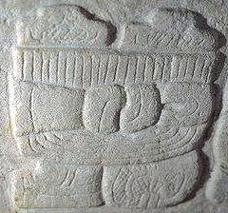

R Villalobos, Tikal emblem Glyph in Stela at Tikal's museum [en:ja:画像:Tikalemblem.jpg](https://en.wikipedia.org/wiki/ja:%E7%94%BB%E5%83%8F:Tikalemblem.jpg) https://upload.wikimedia.org/wikipedia/commons/5/53/Tikalemblem.jpg

**References: (After Wiki)**

*Adams, Richard E.W. (2000). "Introduction to a Survey of the Native Prehistoric Cultures of Mesoamerica". In Richard E.W. Adams; Murdo J. Macleod. The Cambridge History of the Native Peoples of the Americas, Vol. II: Mesoamerica, part 1. Cambridge, UK:* [*Cambridge University Press*](https://en.wikipedia.org/wiki/Cambridge_University_Press)*. pp. 1–44.* [*ISBN*](https://en.wikipedia.org/wiki/International_Standard_Book_Number)[*0-521-35165-0*](https://en.wikipedia.org/wiki/Special:BookSources/0-521-35165-0)*.* [*OCLC*](https://en.wikipedia.org/wiki/OCLC)[*33359444*](https://www.worldcat.org/oclc/33359444)*.*

*Andrews, E. Wyllys; William L. Fash (2005). "Issues in Copán Archaeology". In E. Wyllys Andrews; William L. Fash. Copán: The History of an Ancient Maya Kingdom. Santa Fe and Oxford:* [*School of American Research*](https://en.wikipedia.org/wiki/School_of_American_Research) *Press and James Currey Ltd. pp. 395–425.* [*ISBN*](https://en.wikipedia.org/wiki/International_Standard_Book_Number)[*0-85255-981-X*](https://en.wikipedia.org/wiki/Special:BookSources/0-85255-981-X)*.* [*OCLC*](https://en.wikipedia.org/wiki/OCLC)[*56194789*](https://www.worldcat.org/oclc/56194789)*.*

*Banco de Guatemala.* [*"Monedas"*](http://www.banguat.gob.gt/inc/ver.asp?id=/monedasybilletes/ilustraciones-11-denominaciones.htm&e=40306) *(in Spanish). Banco de Guatemala. Retrieved 2009-11-13.*

*Berlin, Heinrich (April 1967). "The Destruction of Structure 5D-33-1st at Tikal". American Antiquity. Washington, D. C., USA: Society for American Archaeology.* ***32*** *(2): 241–242.* [*doi*](https://en.wikipedia.org/wiki/Digital_object_identifier)*:*[*10.2307/277915*](https://doi.org/10.2307%2F277915)*.* [*ISSN*](https://en.wikipedia.org/wiki/International_Standard_Serial_Number)[*0002-7316*](https://www.worldcat.org/issn/0002-7316)*.* [*JSTOR*](https://en.wikipedia.org/wiki/JSTOR)[*277915*](https://www.jstor.org/stable/277915)*.* [*OCLC*](https://en.wikipedia.org/wiki/OCLC)[*754651089*](https://www.worldcat.org/oclc/754651089)*.* (subscription required)

[*Coe, Michael D.*](https://en.wikipedia.org/wiki/Michael_D._Coe) *(1999). The Maya. Ancient peoples and places series (6th edition, fully revised and expanded ed.). London and New York:* [*Thames & Hudson*](https://en.wikipedia.org/wiki/Thames_%26_Hudson)*.* [*ISBN*](https://en.wikipedia.org/wiki/International_Standard_Book_Number)[*0-500-28066-5*](https://en.wikipedia.org/wiki/Special:BookSources/0-500-28066-5)*.* [*OCLC*](https://en.wikipedia.org/wiki/OCLC)[*59432778*](https://www.worldcat.org/oclc/59432778)*.*

[*Coe, William R.*](https://en.wikipedia.org/wiki/William_R._Coe_(archaeologist)) *(1988) [1967]. Tikal: Guía de las Antiguas Ruinas Mayas (in Spanish). Guatemala: Piedra Santa.* [*ISBN*](https://en.wikipedia.org/wiki/International_Standard_Book_Number)[*84-8377-246-9*](https://en.wikipedia.org/wiki/Special:BookSources/84-8377-246-9)*.*

*Drew, David (1999). The Lost Chronicles of the Mayan Kings. Los Angeles:* [*University of California Press*](https://en.wikipedia.org/wiki/University_of_California_Press)*.*

*Fash, William L.; Ricardo Agurcia Fasquelle (2005). "Contributions and Controversies in the Archaeology and History of Copán". In E. Wyllys Andrews; William L. Fash. Copán: The History of an Ancient Maya Kingdom. Santa Fe and Oxford:* [*School of American Research*](https://en.wikipedia.org/wiki/School_of_American_Research) *Press and James Currey Ltd. pp. 3–32.* [*ISBN*](https://en.wikipedia.org/wiki/International_Standard_Book_Number)[*0-85255-981-X*](https://en.wikipedia.org/wiki/Special:BookSources/0-85255-981-X)*.* [*OCLC*](https://en.wikipedia.org/wiki/OCLC)[*56194789*](https://www.worldcat.org/oclc/56194789)*.*

*Gill, Richardson B. (2000). The Great Maya Droughts: Water, Life, and Death. Albuquerque:* [*University of New Mexico Press*](https://en.wikipedia.org/wiki/University_of_New_Mexico_Press)*.* [*ISBN*](https://en.wikipedia.org/wiki/International_Standard_Book_Number)[*0-8263-2194-1*](https://en.wikipedia.org/wiki/Special:BookSources/0-8263-2194-1)*.* [*OCLC*](https://en.wikipedia.org/wiki/OCLC)[*43567384*](https://www.worldcat.org/oclc/43567384)*.*

*Hammond, Norman (2000). "The Maya Lowlands: Pioneer Farmers to Merchant Princes". In Richard E.W. Adams; Murdo J. Macleod. The Cambridge History of the Native Peoples of the Americas, Vol. II: Mesoamerica, part 1. Cambridge, UK:* [*Cambridge University Press*](https://en.wikipedia.org/wiki/Cambridge_University_Press)*. pp. 197–249.* [*ISBN*](https://en.wikipedia.org/wiki/International_Standard_Book_Number)[*0-521-35165-0*](https://en.wikipedia.org/wiki/Special:BookSources/0-521-35165-0)*.* [*OCLC*](https://en.wikipedia.org/wiki/OCLC)[*33359444*](https://www.worldcat.org/oclc/33359444)*.*

*Harrison, Peter D. (2006). "Maya Architecture at Tikal". In* [*Nikolai Grube*](https://en.wikipedia.org/wiki/Nikolai_Grube)*. Maya: Divine Kings of the Rain Forest. Eva Eggebrecht and Matthias Seidel (assistant eds.). Köln:* [*Könemann*](https://en.wikipedia.org/w/index.php?title=K%C3%B6nemann&action=edit&redlink=1)*. pp. 218–231.* [*ISBN*](https://en.wikipedia.org/wiki/International_Standard_Book_Number)[*3-8331-1957-8*](https://en.wikipedia.org/wiki/Special:BookSources/3-8331-1957-8)*.* [*OCLC*](https://en.wikipedia.org/wiki/OCLC)[*71165439*](https://www.worldcat.org/oclc/71165439)*.*

*Jones, Grant D. (1998).* [*The Conquest of the Last Maya Kingdom*](https://books.google.com/books?id=PeOWl54Mt7UC&pg=RA2-PT82#v=onepage&q&f=false)*. Stanford, California, USA: Stanford University Press.* [*ISBN*](https://en.wikipedia.org/wiki/International_Standard_Book_Number)[*9780804735223*](https://en.wikipedia.org/wiki/Special:BookSources/9780804735223)*.* [*OCLC*](https://en.wikipedia.org/wiki/OCLC)[*38747674*](https://www.worldcat.org/oclc/38747674)*.*

*Kelly, Joyce (1996). An Archaeological Guide to Northern Central America: Belize, Guatemala, Honduras, and El Salvador. Norman:* [*University of Oklahoma Press*](https://en.wikipedia.org/wiki/University_of_Oklahoma_Press)*.* [*ISBN*](https://en.wikipedia.org/wiki/International_Standard_Book_Number)[*0-8061-2858-5*](https://en.wikipedia.org/wiki/Special:BookSources/0-8061-2858-5)*.* [*OCLC*](https://en.wikipedia.org/wiki/OCLC)[*34658843*](https://www.worldcat.org/oclc/34658843)*.*

[*Kerr, Justin*](https://en.wikipedia.org/w/index.php?title=Justin_Kerr&action=edit&redlink=1) *(n.d.).* [*"A Precolumbian Portfolio"*](http://research.famsi.org/kerrportfolio.html) *(online database). FAMSI Research Materials. Foundation for the Advancement of Mesoamerican Studies, Inc. Retrieved 2007-06-13.*

*Looper, Matthew G. (1999). "New Perspectives on the Late Classic Political History of Quirigua, Guatemala". Ancient Mesoamerica. Cambridge and New York:* [*Cambridge University Press*](https://en.wikipedia.org/wiki/Cambridge_University_Press)*.* ***10*** *(2): 263–280.* [*doi*](https://en.wikipedia.org/wiki/Digital_object_identifier)*:*[*10.1017/S0956536199101135*](https://doi.org/10.1017%2FS0956536199101135)*.* [*ISSN*](https://en.wikipedia.org/wiki/International_Standard_Serial_Number)[*0956-5361*](https://www.worldcat.org/issn/0956-5361)*.* [*OCLC*](https://en.wikipedia.org/wiki/OCLC)[*86542758*](https://www.worldcat.org/oclc/86542758)*.*

*Looper, Matthew G. (2003). Lightning Warrior: Maya Art and Kingship at Quirigua. Linda Schele series in Maya and pre-Columbian studies. Austin:* [*University of Texas Press*](https://en.wikipedia.org/wiki/University_of_Texas_Press)*.* [*ISBN*](https://en.wikipedia.org/wiki/International_Standard_Book_Number)[*0-292-70556-5*](https://en.wikipedia.org/wiki/Special:BookSources/0-292-70556-5)*.* [*OCLC*](https://en.wikipedia.org/wiki/OCLC)[*52208614*](https://www.worldcat.org/oclc/52208614)*.*

[*Martin, Simon*](https://en.wikipedia.org/wiki/Simon_Martin_(Mayanist))*;* [*Nikolai Grube*](https://en.wikipedia.org/wiki/Nikolai_Grube) *(2000). Chronicle of the Maya Kings and Queens: Deciphering the Dynasties of the Ancient Maya. London and New York:* [*Thames & Hudson*](https://en.wikipedia.org/wiki/Thames_%26_Hudson)*.* [*ISBN*](https://en.wikipedia.org/wiki/International_Standard_Book_Number)[*0-500-05103-8*](https://en.wikipedia.org/wiki/Special:BookSources/0-500-05103-8)*.* [*OCLC*](https://en.wikipedia.org/wiki/OCLC)[*47358325*](https://www.worldcat.org/oclc/47358325)*.*

[*Martin, Simon*](https://en.wikipedia.org/wiki/Simon_Martin_(Mayanist))*;* [*Nikolai Grube*](https://en.wikipedia.org/wiki/Nikolai_Grube) *(2008). Chronicle of the Maya Kings and Queens: Deciphering the Dynasties of the Ancient Maya (2nd edn (revised) ed.). London and New York:* [*Thames & Hudson*](https://en.wikipedia.org/wiki/Thames_%26_Hudson)*.* [*ISBN*](https://en.wikipedia.org/wiki/International_Standard_Book_Number)[*978-0-500-28726-2*](https://en.wikipedia.org/wiki/Special:BookSources/978-0-500-28726-2)*.* [*OCLC*](https://en.wikipedia.org/wiki/OCLC)[*191753193*](https://www.worldcat.org/oclc/191753193)*.*

*Martínez, Horacio; David Webster; Jay Silverstein; Timothy Murtha; Kirk Straight; Irinna Montepeque (2004). J.P. Laporte; B. Arroyo; H. Escobedo; H. Mejía, eds.* [*"Reconocimiento en la periferia de Tikal: Los Terraplenes Norte, Oeste y Este, nuevas exploraciones y perspectivas"*](https://web.archive.org/web/20110914060753/http:/www.asociaciontikal.com/pdf/56.03%20-%20Horacio%20-%20en%20PDF.pdf) *(PDF). XVII Simposio de Investigaciones Arqueológicas en Guatemala, 2003 (in Spanish). Museo Nacional de Arqueología y Etnología, Guatemala. pp. 635–641. Archived from* [*the original*](http://www.asociaciontikal.com/pdf/56.03%20-%20Horacio%20-%20en%20PDF.pdf) *(*[*PDF*](https://en.wikipedia.org/wiki/PDF) *online publication) on 14 September 2011. Retrieved 24 June 2009.*

[*Means, Philip Ainsworth*](https://en.wikipedia.org/wiki/Philip_Ainsworth_Means) *(1917).* [*History of the Spanish Conquest of Yucatan and of the Itzas*](https://en.wikisource.org/wiki/History_of_the_Spanish_Conquest_of_Yucatan_and_of_the_Itzas)*. Papers of the Peabody Museum of American Archaeology and Ethnology, Harvard University.* ***VII****. Cambridge, Massachusetts, USA: Peabody Museum of Archaeology and Ethnology.* [*OCLC*](https://en.wikipedia.org/wiki/OCLC)[*681599*](https://www.worldcat.org/oclc/681599)*.*

[*Miller, Mary Ellen*](https://en.wikipedia.org/wiki/Mary_Miller_(art_historian)) *(1999). Maya Art and Architecture. London and New York:* [*Thames & Hudson*](https://en.wikipedia.org/wiki/Thames_%26_Hudson)*.* [*ISBN*](https://en.wikipedia.org/wiki/International_Standard_Book_Number)[*0-500-20327-X*](https://en.wikipedia.org/wiki/Special:BookSources/0-500-20327-X)*.* [*OCLC*](https://en.wikipedia.org/wiki/OCLC)[*41659173*](https://www.worldcat.org/oclc/41659173)*.*

[*Miller, Mary*](https://en.wikipedia.org/wiki/Mary_Miller_(art_historian))*;* [*Karl Taube*](https://en.wikipedia.org/wiki/Karl_Taube) *(1993). The Gods and Symbols of Ancient Mexico and the Maya: An Illustrated Dictionary of Mesoamerican Religion. London:* [*Thames & Hudson*](https://en.wikipedia.org/wiki/Thames_%26_Hudson)*.* [*ISBN*](https://en.wikipedia.org/wiki/International_Standard_Book_Number)[*0-500-05068-6*](https://en.wikipedia.org/wiki/Special:BookSources/0-500-05068-6)*.* [*OCLC*](https://en.wikipedia.org/wiki/OCLC)[*27667317*](https://www.worldcat.org/oclc/27667317)*.*

*Morales, Tirso; Benito Burgos; Miguel Acosta; Sergio Pinelo; Marco Tulio Castellanos; Leopoldo González; Francisco Castañeda; Edy Barrios; Rudy Larios; et al. (2008). J.P. Laporte; B. Arroyo; H. Mejía, eds.* [*"Trabajos realizados por la Unidad de Arqueología del Parque Nacional Tikal, 2006-2007"*](https://web.archive.org/web/20110914041426/http:/www.asociaciontikal.com/pdf/27_-_Tirso_et_al.07.pdf) *(PDF). XXI Simposio de Arqueología en Guatemala, 2007 (in Spanish). Guatemala: Museo Nacional de Arqueología y Etnología: 413–436. Archived from* [*the original*](http://asociaciontikal.com/pdf/27_-_Tirso_et_al.07.pdf) *(*[*PDF*](https://en.wikipedia.org/wiki/PDF)*) on 14 September 2011. Retrieved 21 June 2011.*

*Salisbury, David; Mimi Koumenalis; Barbara Moffett (19 September 2002).* [*"Newly revealed hieroglyphs tell story of superpower conflict in the Maya world"*](https://web.archive.org/web/20141102134600/http:/exploration.vanderbilt.edu/print/pdfs/news/news_dospilas_feature.pdf) *(PDF). Exploration: the online research journal of Vanderbilt University. Nashville, TN:* [*Vanderbilt University*](https://en.wikipedia.org/wiki/Vanderbilt_University) *Office of Science and Research Communications.* [*OCLC*](https://en.wikipedia.org/wiki/OCLC)[*50324967*](https://www.worldcat.org/oclc/50324967)*. Archived from* [*the original*](http://exploration.vanderbilt.edu/print/pdfs/news/news_dospilas_feature.pdf) *(*[*PDF*](https://en.wikipedia.org/wiki/PDF) *online publication) on 2 November 2014. Retrieved 22 September 2009.*

[*Schele, Linda*](https://en.wikipedia.org/wiki/Linda_Schele)*; Peter Mathews (1999). The Code of Kings: The language of seven Maya temples and tombs. New York: Simon & Schuster.* [*ISBN*](https://en.wikipedia.org/wiki/International_Standard_Book_Number)[*978-0-684-85209-6*](https://en.wikipedia.org/wiki/Special:BookSources/978-0-684-85209-6)*.* [*OCLC*](https://en.wikipedia.org/wiki/OCLC)[*41423034*](https://www.worldcat.org/oclc/41423034)*.*

[*Sharer, Robert J.*](https://en.wikipedia.org/wiki/Robert_Sharer)*; Loa P. Traxler (2006). The Ancient Maya (6th, fully revised ed.). Stanford, CA:* [*Stanford University Press*](https://en.wikipedia.org/wiki/Stanford_University_Press)*.* [*ISBN*](https://en.wikipedia.org/wiki/International_Standard_Book_Number)[*0-8047-4817-9*](https://en.wikipedia.org/wiki/Special:BookSources/0-8047-4817-9)*.* [*OCLC*](https://en.wikipedia.org/wiki/OCLC)[*57577446*](https://www.worldcat.org/oclc/57577446)*.*

*Silverstein, Jay; David Webster; Horacio Martinez; Alvaro Soto (2009). Rethinking the Earthworks of Tikal: A Hydraulic Hypothesis for the Classic Maya Polity. Ancient Mesoamerican 20(1), Cambridge Journals.*

*StarWars.com.* [*"Star Wars: Episode IV A New Hope"*](https://web.archive.org/web/20091229025542/http:/www.starwars.com/movies/episode-iv/)*. Lucasfilm Ltd. Archived from* [*the original*](http://www.starwars.com/movies/episode-iv/) *on 2009-12-29. Retrieved 2009-11-13.*

*Torres, Estuardo.* [*"Parque Nacional Tikal"*](https://web.archive.org/web/20091218014941/http:/www.mcd.gob.gt/2009/04/03/parque-nacional-tikal) *(in Spanish). Ministerio de Cultura y Deportes. Archived from* [*the original*](http://www.mcd.gob.gt/2009/04/03/parque-nacional-tikal/) *on 2009-12-18. Retrieved 2014-07-30.*

*UNESCO World Heritage Center.* [*"Tikal National Park"*](http://whc.unesco.org/en/list/64)*. UNESCO World Heritage Center. Retrieved 2009-11-13.*

*Valdés, Juan Antonio; Fahsen, Federico (2005). "Disaster in Sight: The Terminal Classic at Tikal and Uaxactun". In Arthur A. Demarest; Prudence M. Rice; Don S. Rice. The Terminal Classic in the Maya lowlands: Collapse, transition, and transformation. Boulder:* [*University Press of Colorado*](https://en.wikipedia.org/wiki/University_Press_of_Colorado)*. pp. 162–194.* [*ISBN*](https://en.wikipedia.org/wiki/International_Standard_Book_Number)[*0-87081-822-8*](https://en.wikipedia.org/wiki/Special:BookSources/0-87081-822-8)*.* [*OCLC*](https://en.wikipedia.org/wiki/OCLC)[*61719499*](https://www.worldcat.org/oclc/61719499)*.*

*Webster, David L. (2002). The Fall of the Ancient Maya: Solving the Mystery of the Maya Collapse. London:* [*Thames & Hudson*](https://en.wikipedia.org/wiki/Thames_%26_Hudson)*.* [*ISBN*](https://en.wikipedia.org/wiki/International_Standard_Book_Number)[*0-500-05113-5*](https://en.wikipedia.org/wiki/Special:BookSources/0-500-05113-5)*.* [*OCLC*](https://en.wikipedia.org/wiki/OCLC)[*48753878*](https://www.worldcat.org/oclc/48753878)*.*